Name: _________________________________ Test Date: ____________________

Expressions and Equations- Inequalities Summative REVIEW

Domain: Expressions and Equations
- I can understand solving an equation or inequality as a process of answering a question.
- I can write an inequality of the form x > c or x < c to represent a constraint or condition in a real-world or mathematical problem.

Directions: Answer each of the following questions below. Be sure to show all work for each question!
- Circle all answers that make the inequality true: 48 ≤ 5m + 8

- m = 7 b.) m = 8

c.) m = 4.5 d.) m = 10

- Check all of the values of x that make each equation or inequality true.

 | x = 1 | x = 2 | x = 3
2x + 5 = 9
2x + 5 < 9
2x + 5 ≤ 9

- Which inequality is NOT true when x = 6?

a.) 3x ≥ 18 b.) 2x < 12

c.) 2 + x < 10 d.) x - 2 ≤ 12

4.) In order to win a weight lifting contest, Rhonda must lift more than 290 pounds. If x represents the amount of weight Rhonda lifted, choose the inequality that represents this situation.
a. x ≥ 290
b. x > 290
c. x < 290
d. x ≤ 290

- Graph all the solutions for the following inequality. Remember to solve first to determine the possible solutions for the value of d to make the inequality true.

$\frac{d}{8}$ ≥ 5 Solution to inequality: __________________
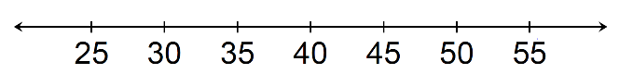
- Graph all the solutions for the following inequality. Remember to solve first to determine the possible solutions for the value of m to make the inequality true.

184 < m + 59 Solution to inequality: __________________

- Solve and state all of the values for when the following equations/inequalities will be true and when they will be false.
a.) 9y = 108

True_________________________________________________________________________________
False ________________________________________________________________________________

- c – 43 < 51

True_________________________________________________________________________________
False ________________________________________________________________________________

8.) All seventh graders must do at least 45 crunches in one minute.
a. Write an inequality to represent this situation. Let c represent the number of crunches.

________________________________________

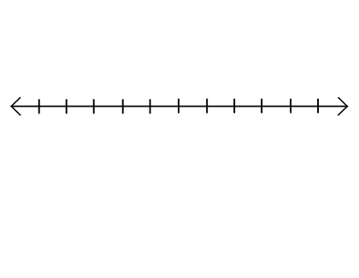
b. Graph the inequality on the number line below.

42 43 44 45 46 47 48 49 50 51 52

- Gia is buying new tennis shoes. Her mom says she should spend at least $60, but less than $120 on a pair of shoes. Let m represent the amount of money she spent.

This situation is represented by the inequality 60 ≤ m < 120
Graph the inequality on the number line below.

50 60 70 80 90 100 110 120 130 140 150

